DROP TABLE

The DROP TABLE statement is used to drop an existing table in a database.

Syntax: DROP TABLE table_name;

Eg : drop table datasetfortechnicalpurpose;

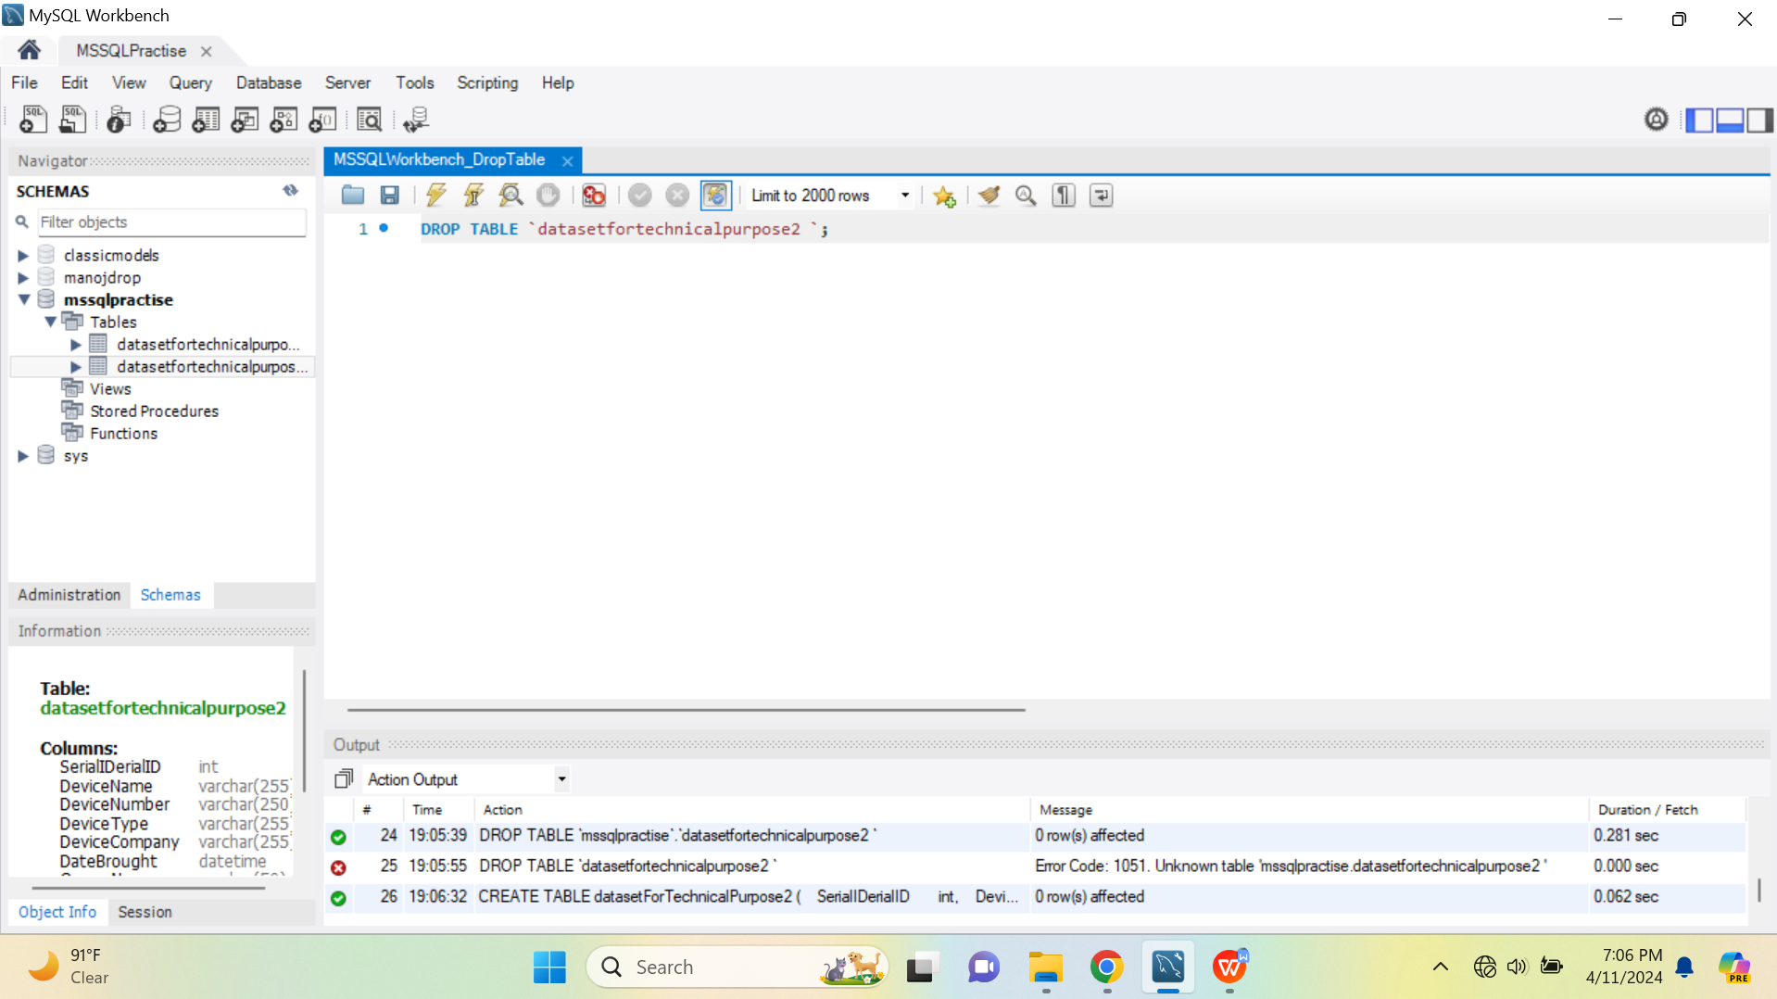

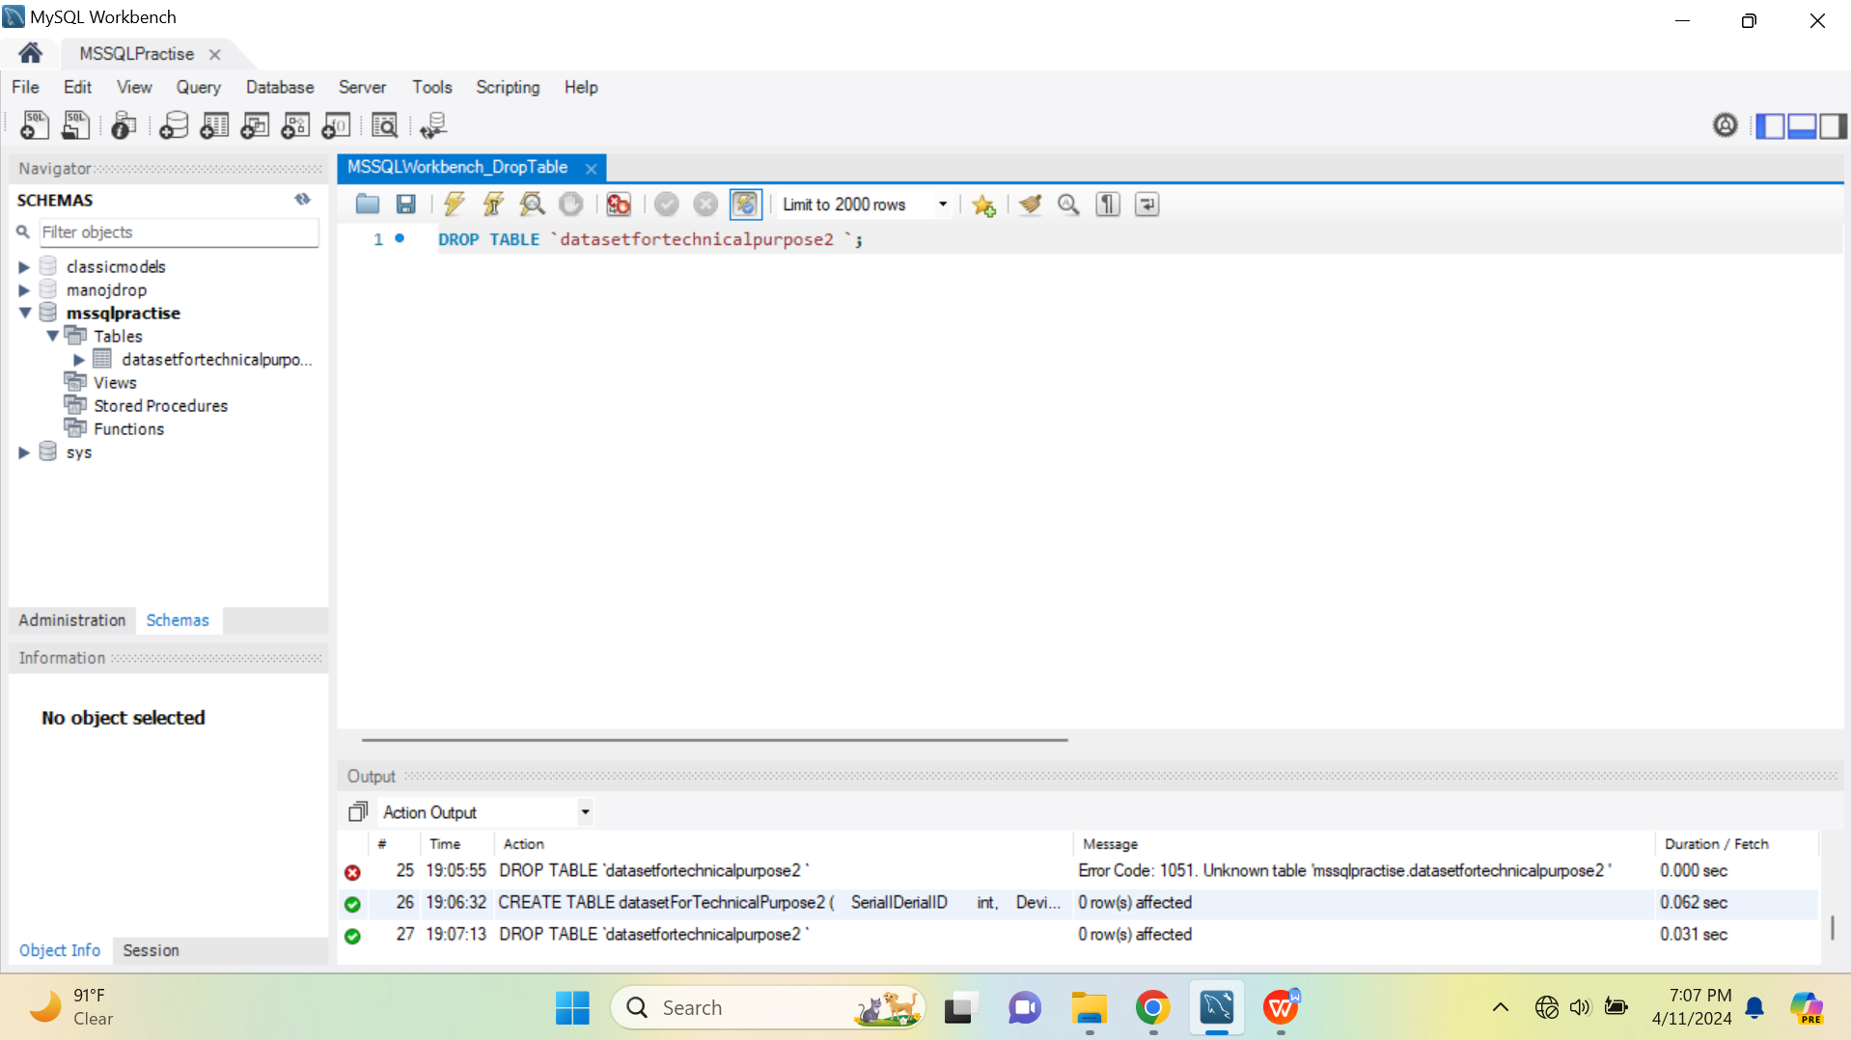

Note: Be careful before dropping a table. Deleting a table will result in loss of complete information stored in the table!

